2025

AZLAN SAMEER ULLAH (242800)

ABDULLAH AKRAM (242788)

5/24/2025

PROJECT - DOCUMENTATION

**Samsung Mobile Comparison and Ordering System**

**Project Documentation**

**1. Project Title**

**Samsung Mobile Comparison and Ordering System**

**2. Scope of the Software**

This web-based platform enables users to:

* Compare specifications of Samsung smartphones.
* Create and manage user profiles.
* Place orders for selected devices.
* Submit reviews and ratings.
* Manage a shopping cart.
* Contact support via a form.

**3. Functional Requirements**

| **Feature** | **Description** |
| --- | --- |
| **User Profile Management** | Save user details (userId, name, email, phone, address, etc.) via profile.php. |
| **Product Comparison** | Compare up to 3 phones side-by-side (display, processor, camera, etc.). |
| **Order Placement** | Submit orders with order ID, user ID, date, and total amount via orders.php. |
| **Review System** | Submit ratings (Good/Poor) and comments via reviews.php. |
| **Shopping Cart** | Add/remove items and calculate total price dynamically using JavaScript. |
| **Contact Form** | Send messages to support via contact.php. |

**4. Entity-Relationship Diagram (ERD)**

**Insert ERD Image Here**

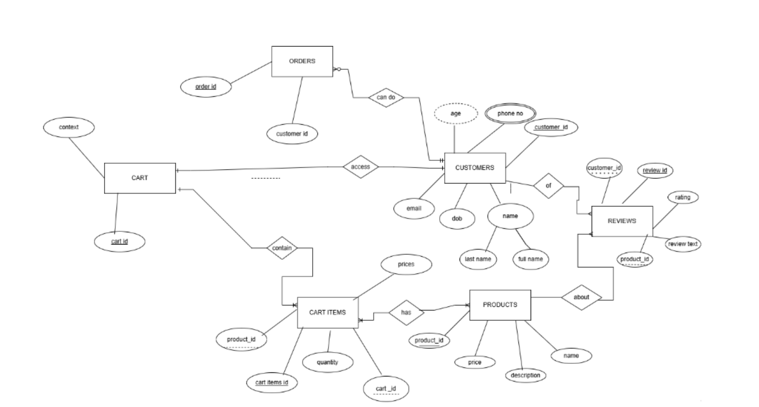

**Entities**:

* **Profiles**: userId (PK), fullName, firstName, lastName, phone, email, dob, address, age
* **Orders**: order_Id (PK), orderUserId (FK), orderDate, totalAmount
* **Reviews**: id (PK), reviewUserid (FK), rating, comment
* **Contact**: id (PK), name, email, message, created_at

**Relationships**:

* **Profiles** ↔ **Orders**: One-to-Many (One user can place multiple orders).
* **Profiles** ↔ **Reviews**: One-to-Many (One user can submit multiple reviews).

**5. Screenshots**

1. **Homepage**  
   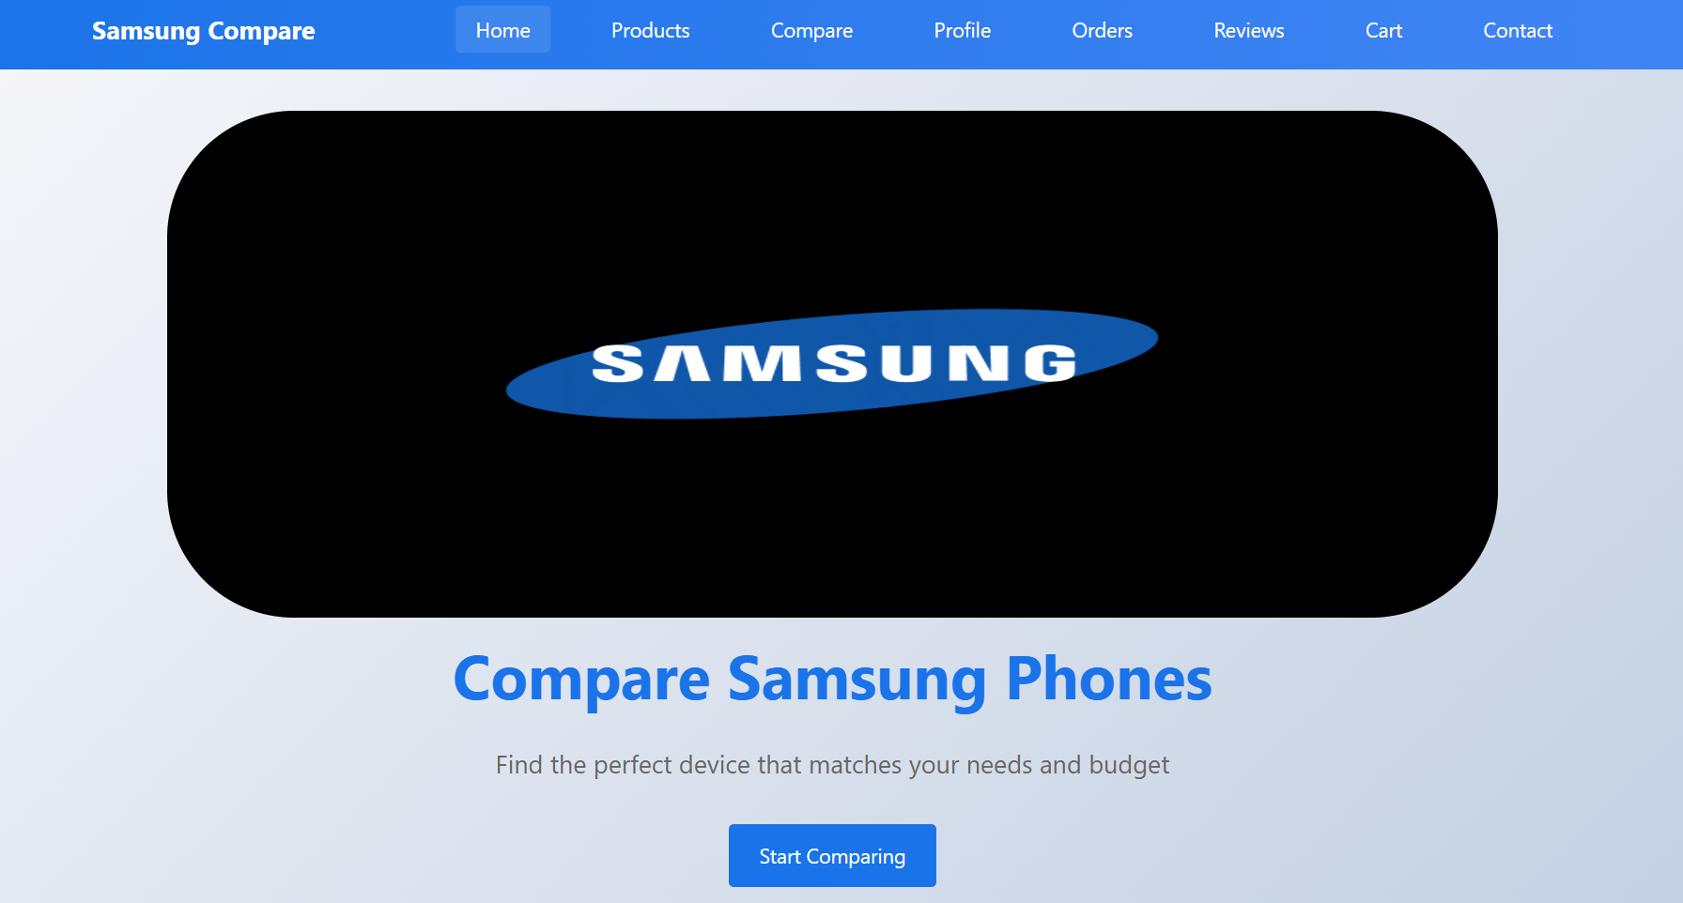  
   *(Description: Landing page with a hero image, features section, and navigation bar.)*
2. **Product Comparison**  
   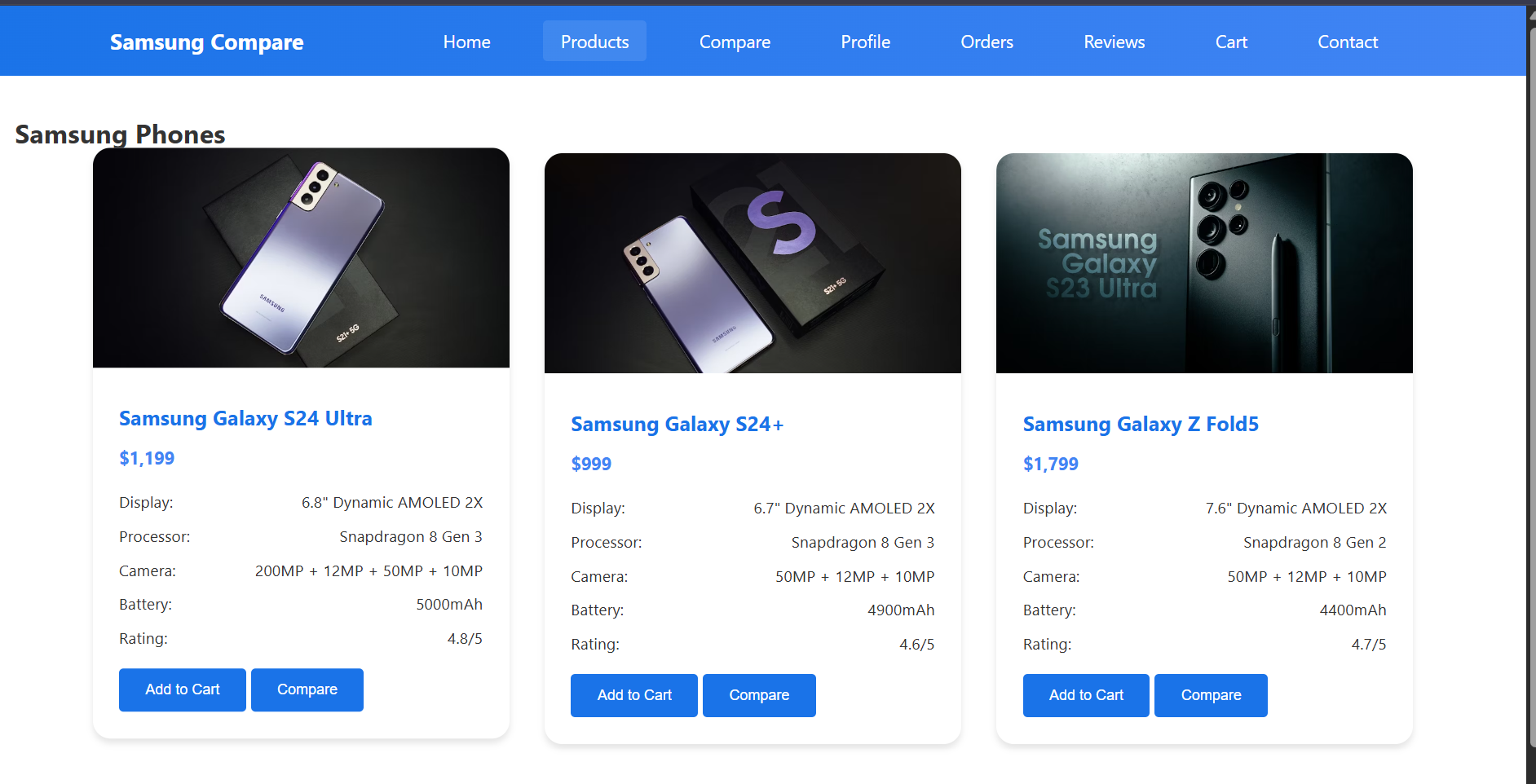  
   **for comparison table:**

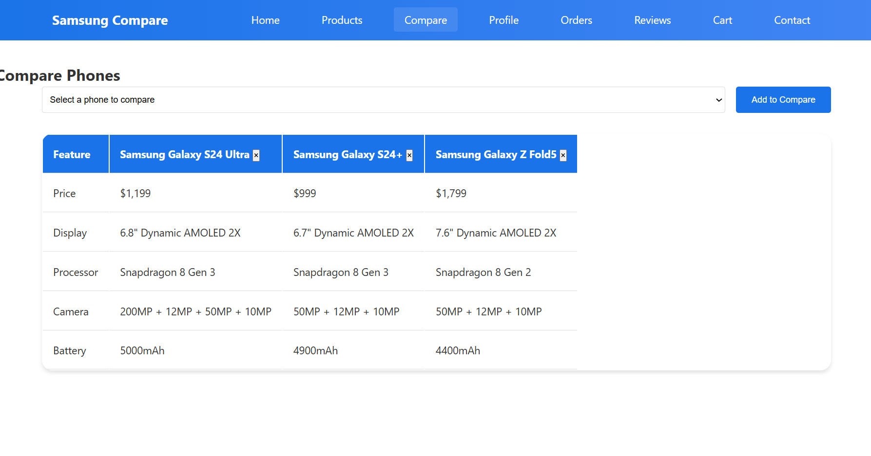

*(Description: Table comparing specifications of selected phones.)*

1. **Profile Form**  
   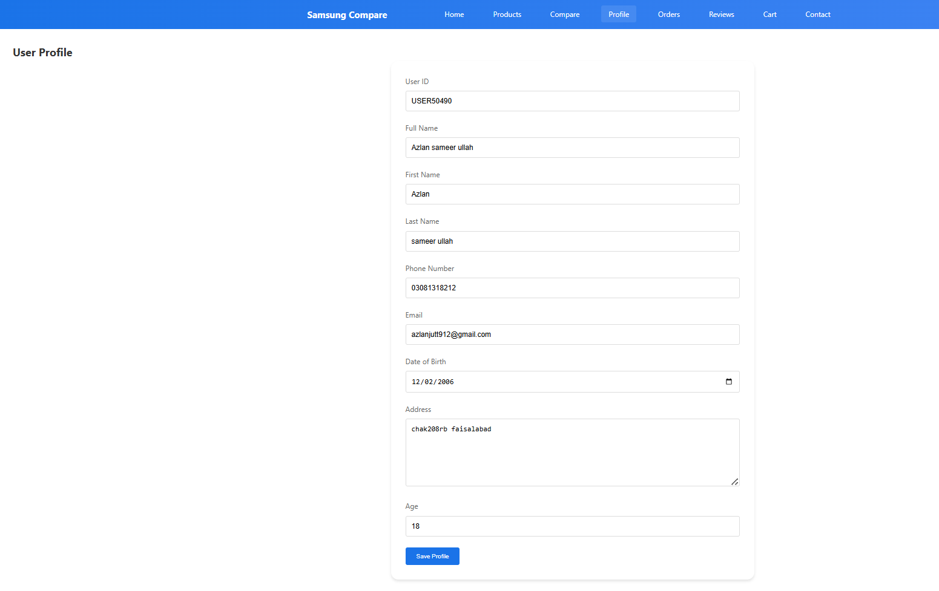

**Backend Database store :**

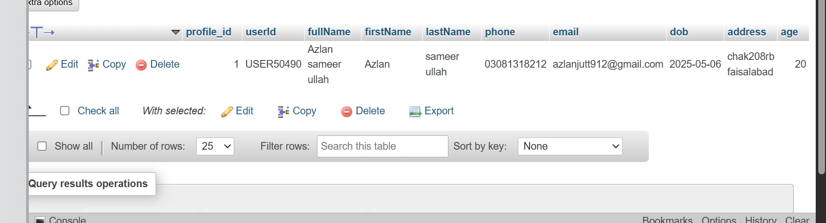

1. **Shopping Cart**  
   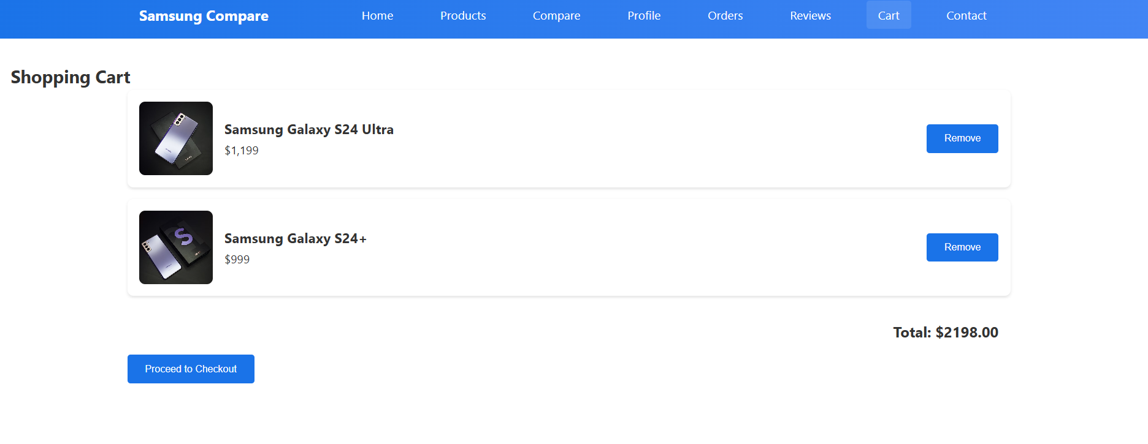  
   *(Description: Cart showing selected items and total amount.)*
2. **Order Page :**

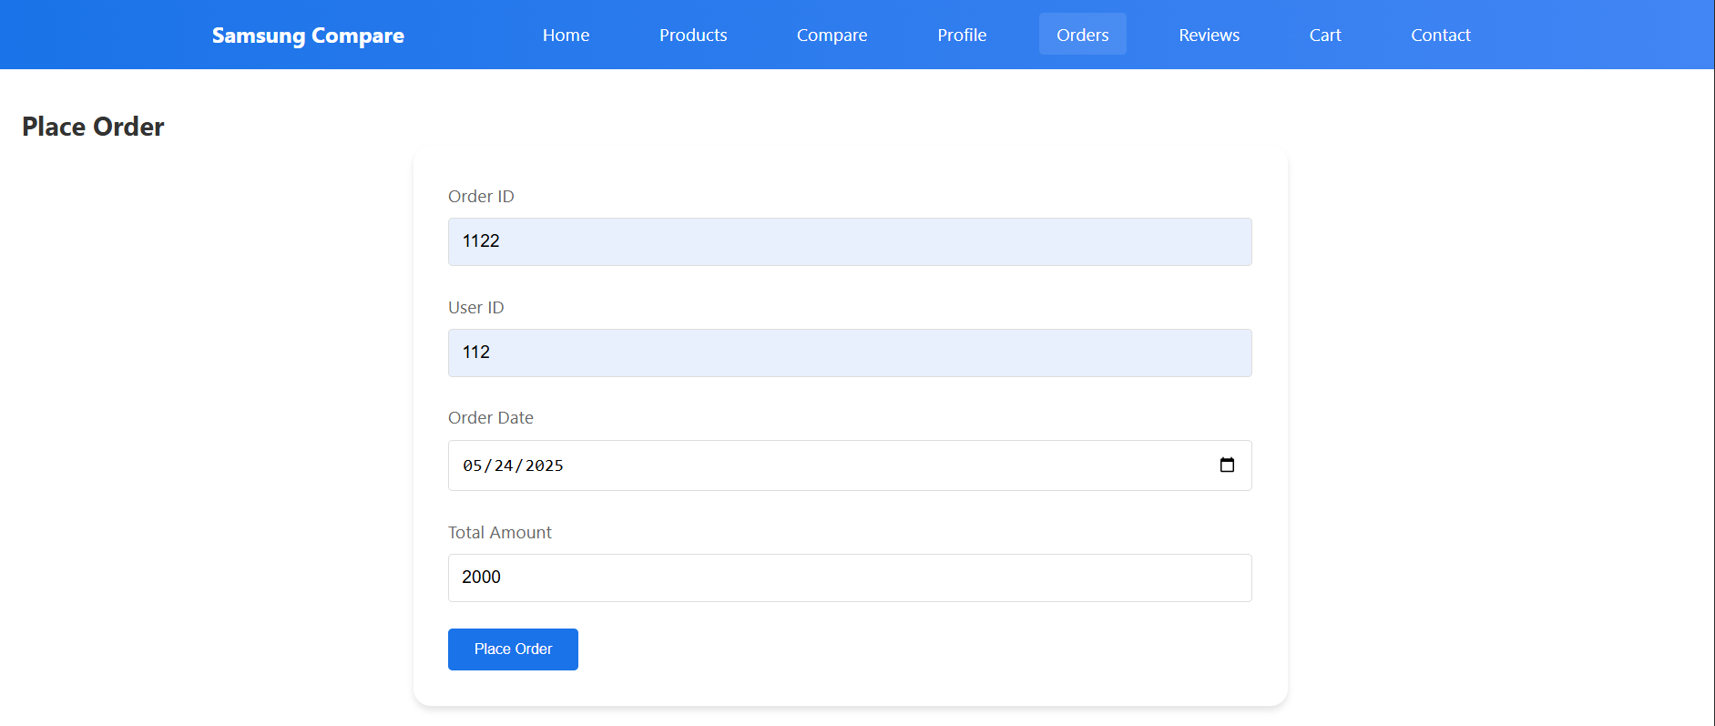

**Backend data-base :**

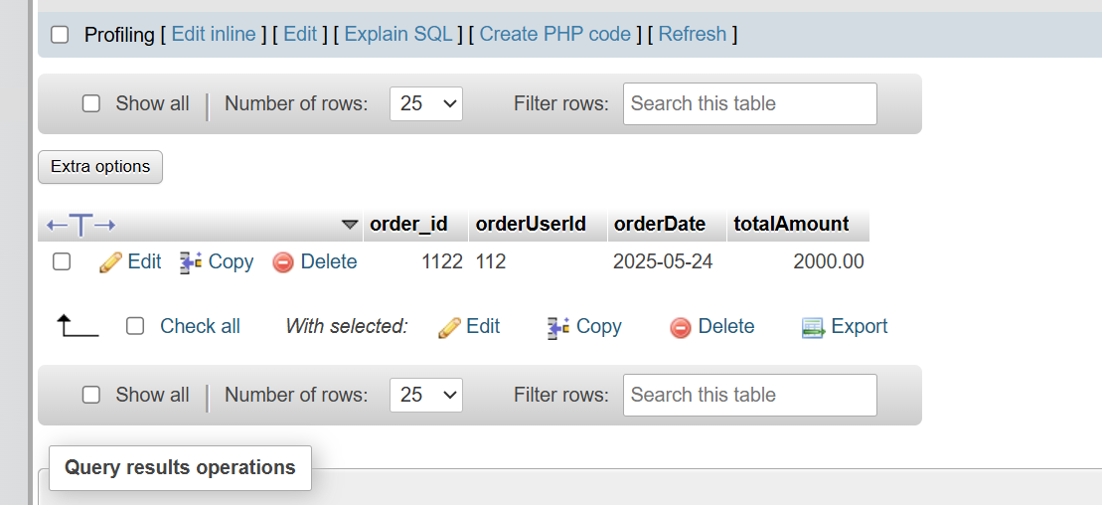

1. **Review Page** :

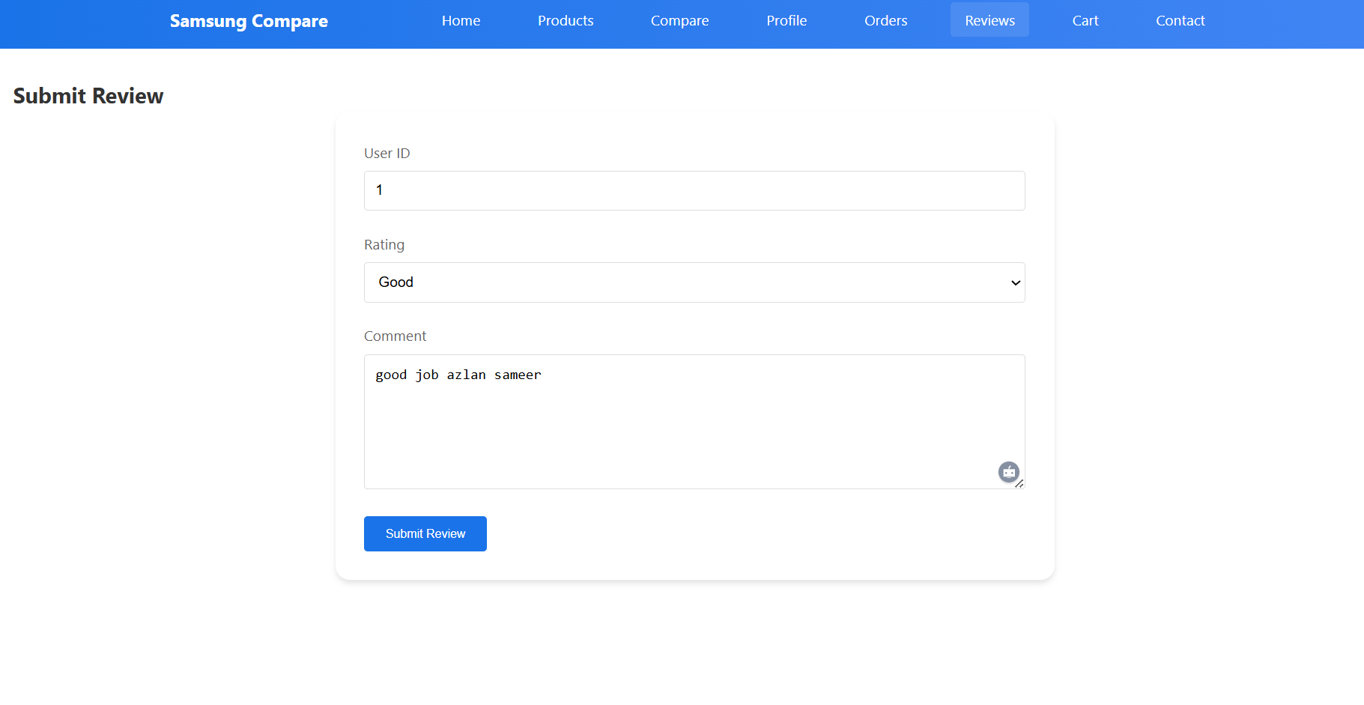

**Backend data-base:**

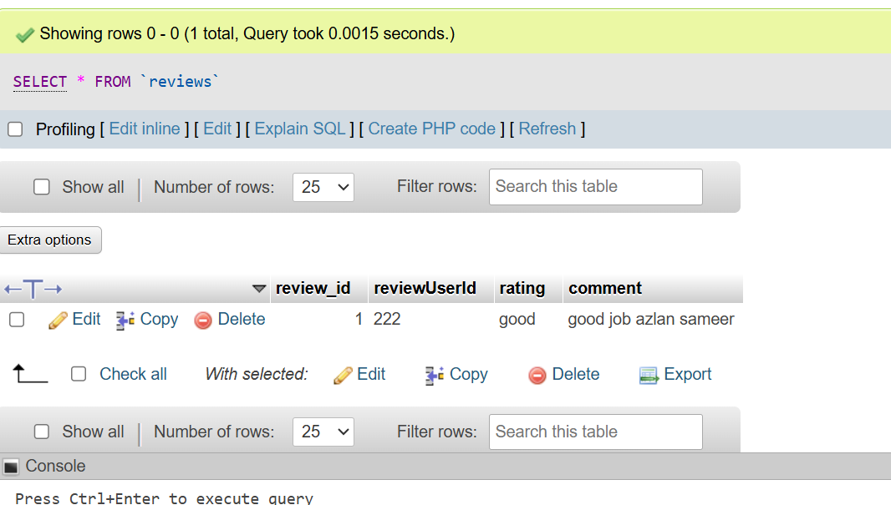

1. **Contact page :** 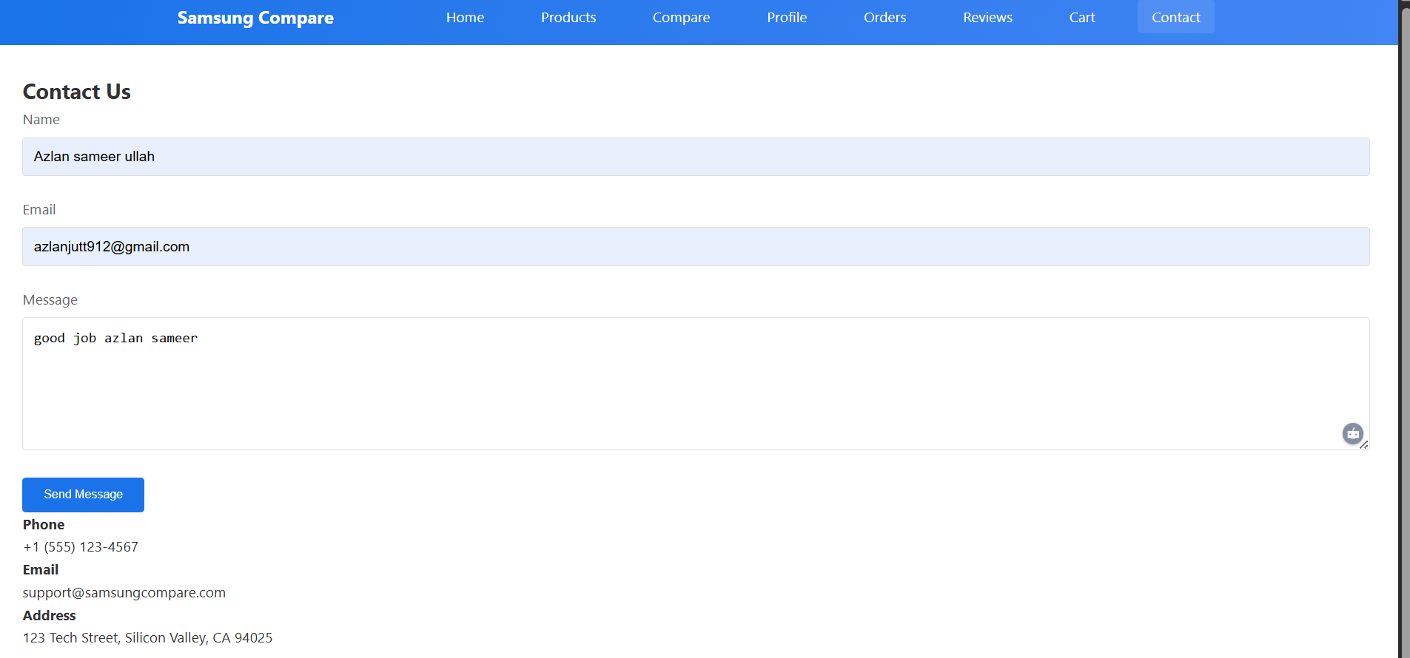

**Backend data-base:**

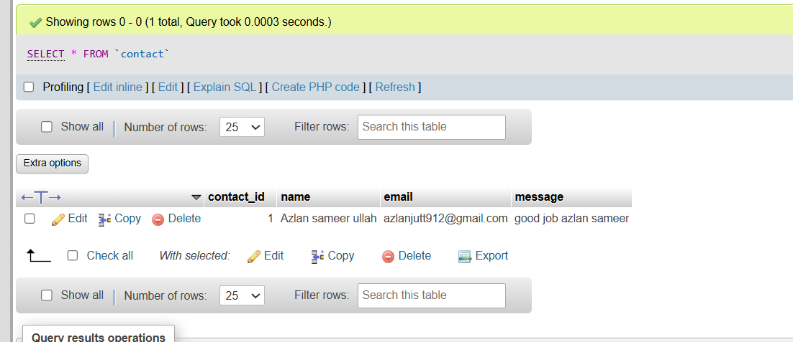

**6. Detailed Documentation**

**6.1 Technologies Used**

* **Frontend**: HTML5, CSS3, JavaScript
* **Backend**: PHP
* **Database**: MySQL

**6.2 Key Features**

* **Dynamic Product Display**: Products are rendered using JavaScript based on hardcoded data in index.html.
* **Form Handling**:
  + Success/error alerts using PHP and JavaScript.
* **Cart Management**: Uses JavaScript to add/remove items and calculate totals.

**6.3 Database Schema**

Sql

CREATE TABLE IF NOT EXISTS Orders (

order_id INT AUTO_INCREMENT PRIMARY KEY,

orderUserId VARCHAR(50) NOT NULL,

orderDate DATE NOT NULL,

totalAmount DECIMAL(10,2) NOT NULL

);

CREATE TABLE IF NOT EXISTS Reviews (

review_id INT AUTO_INCREMENT PRIMARY KEY,

reviewUserId VARCHAR(50) NOT NULL,

rating ENUM('good', 'poor') NOT NULL,

comment TEXT NOT NULL

);

CREATE TABLE IF NOT EXISTS Profiles (

profile_id INT AUTO_INCREMENT PRIMARY KEY,

userId VARCHAR(50) NOT NULL,

fullName VARCHAR(100) NOT NULL,

firstName VARCHAR(50) NOT NULL,

lastName VARCHAR(50) NOT NULL,

phone VARCHAR(20) NOT NULL,

email VARCHAR(100) NOT NULL,

dob DATE NOT NULL,

address TEXT NOT NULL,

age INT NOT NULL

);

CREATE TABLE IF NOT EXISTS Contact (

contact_id INT AUTO_INCREMENT PRIMARY KEY,

name VARCHAR(100) NOT NULL,

email VARCHAR(100) NOT NULL,

message TEXT NOT NULL

);

**6.4 Limitations and Improvements**

* **Limitations**:
  + Products are hardcoded (not fetched from a database).
  + Basic SQL injection prevention (upgrade to prepared statements).
* **Improvements**:
  + Add user authentication.
  + Integrate payment gateway for orders.